Task: Think of some questions you would like to ask a strongman.
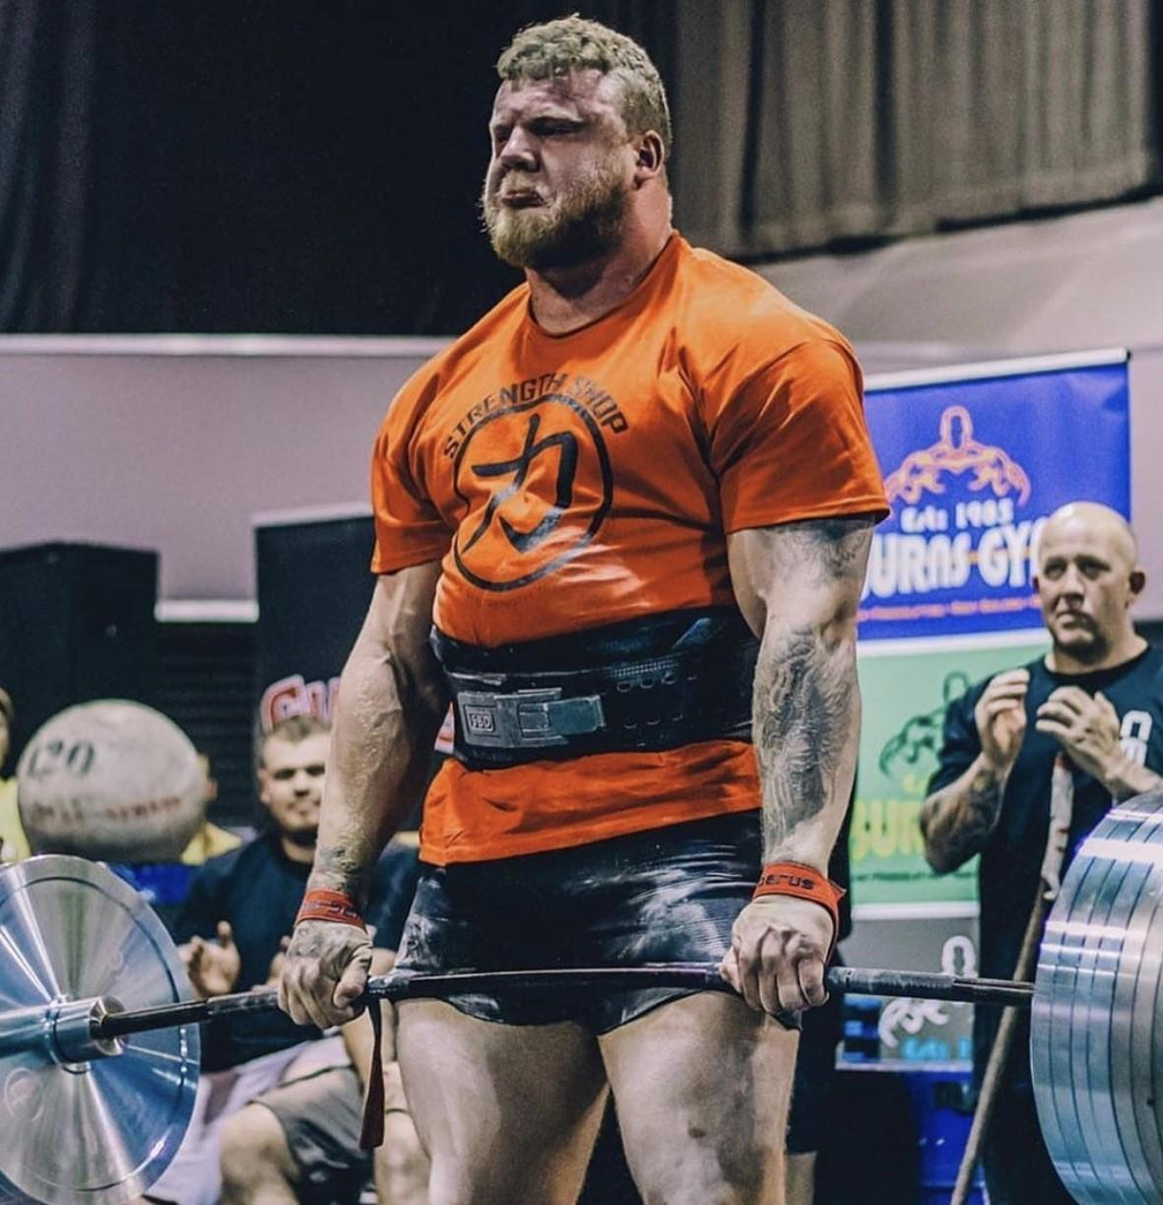

Tom Stoltman is a strongman from Scotland. You may have seen him on Television over Christmas, if you watched the World’s Strongest Man. He did amazing as he came Second. So, until the next tournament later this year, he is the second strongest man in the world!
Tom was diagnosed with Autism as a young child. He now wants to use this new fame to promote Autism. More importantly share his story of having Autism and becoming the second strongest man in the world. When I heard this, I got in contact with him and he replied immediately. Saying he would love it answer questions from Laleham Gap pupils.
So, your task is to think of some questions you would like to ask him. When you have thought of some, email them to me.

Many Thanks

Mr Welsh

